BSc (Hons) in Computing

Level C/I/H



**INDIVIDUAL ASSIGNMENT**

**Module Code & Title:**

**Prepared By: [Mohamed Zafir Sharaz] [(CB009775 )]**

**Date of Submission: 14th August 2023**

**Instructor: Vipula S Anandapiya**

**Word Count: 341**

|  |  |  |
| --- | --- | --- |
| **MARKING CRITERIA** | **%** | **MARKS OBTAINED** |
|  |  |  |
|  |  |  |
|  |  |  |
|  |  |  |
|  |  |  |
|  |  |  |
|  |  |  |
| **TOTAL (%)** | |  |

Table of Contents

Introduction 3

Development 3

Lighthouse Test Report 4

Screenshots 10

Activity diagram 12

Conclusion 13

# Introduction

The project TurtleMe is a simple and easy to use webapp that was developed and designed with HTML, CSS and JavaScript to showcase the turtle hatcheries in Sri Lanka to tourists. This application consists of 13 webpages.

* The home page
* Turtle categories page
* Hikkaduwa turtle hatchery page
* Threats to turtles
* Other turtle hatcheries pages
  + Kosgoda
  + Bentota
* Purchase and Donate page
* Contact us page
* Submission page
* Tickets page
* Details page
* Payment Page
* Confirmation page

Tickets, details, payment and confirmation pages are developed using Alpine Js, a JavaScript library that is useful for creating JavaScript applications. All three pages except confirmation page contains a form which helps users to book tickets to Hikkaduwa turtle hatchery from the website.

# Development

The application is designed to meet the assignment criteria and constructed using HTML, CSS, and JavaScript, but because JavaScript is the primary requirement, the newly added four pages include JavaScript code for verifying and saving data in local storage.

The form will extract information on ticket booking details, personal details, and payment details and save all of that information in local storage by a data store in an array structure that was established in the data store. In addition to that, an external library it is imported in order to add flags to mobile number form that displays all the flags with their country code.

Hosted Link: <https://zafir8.github.io/turtle/>

GitHub Link: <https://github.com/Zafir8/turtle>

The application is fully functional on GitHub at the time and date: 1:15 AM 13/08/2023.

# Lighthouse Test Report

Home Page Report

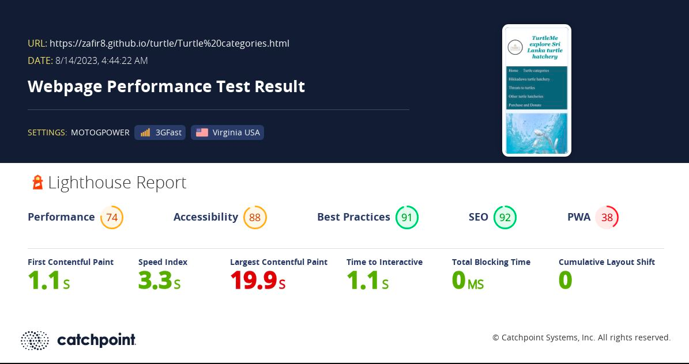

Turtle Categories

hikkaduwa turtle hatchery

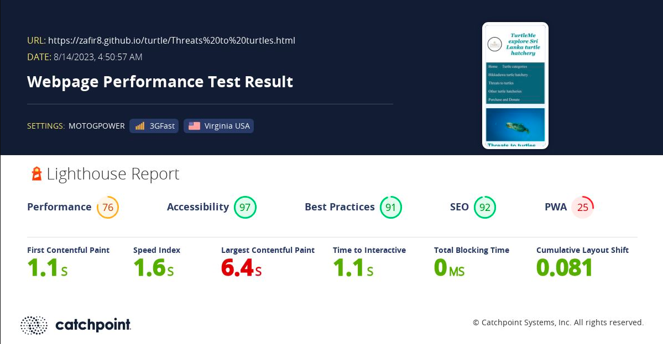

Threats to Turtle

kosgoda turtle hatchery

Purchase Page Report

Bentota Page Report

Tickets page report

Details page report

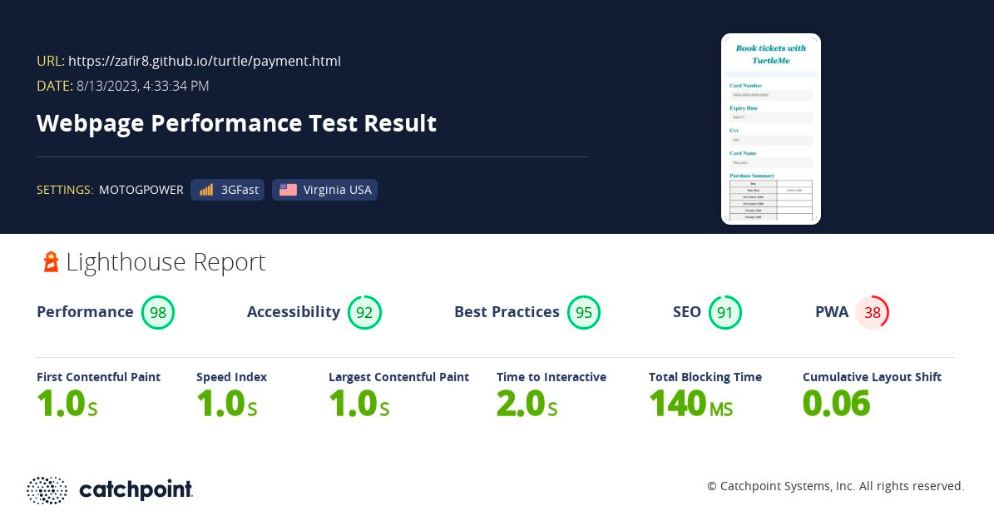

Payment Page Report

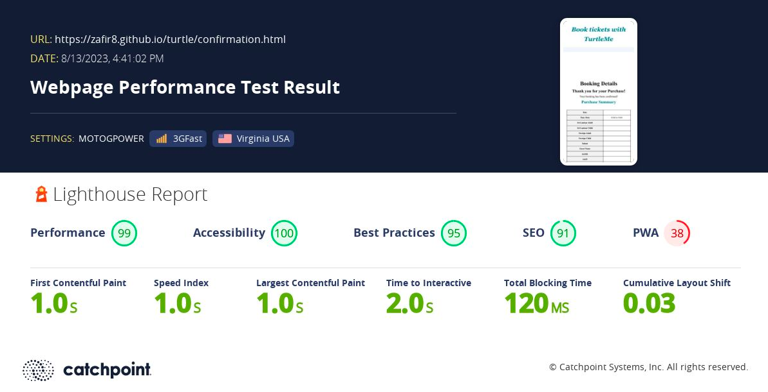

Confirmation page report

# Screenshots

Details page

Tickets Page

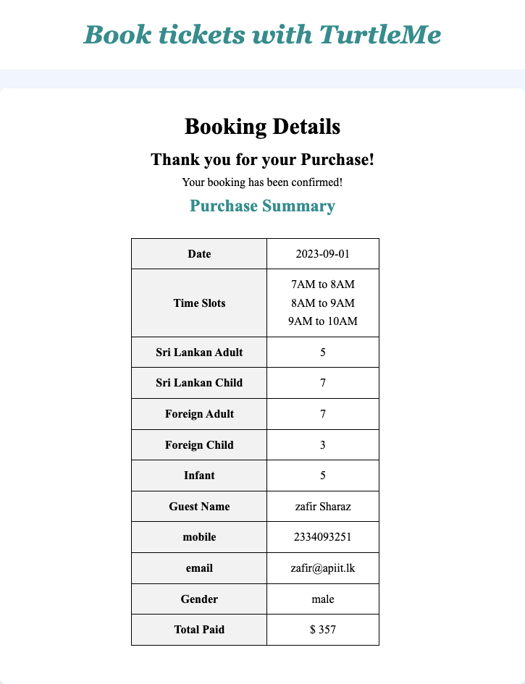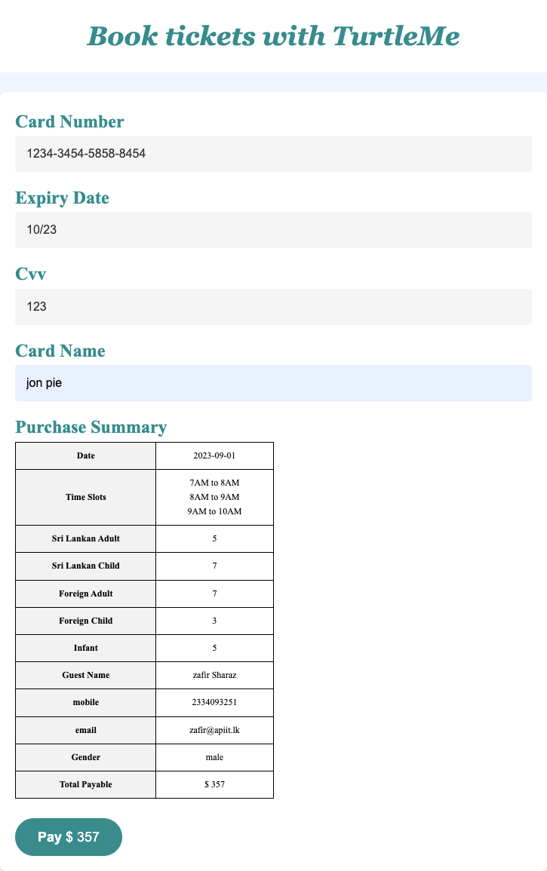

confirmation page

Payment Page

# A diagram of a process Description automatically generatedActivity diagram

# Conclusion

In Conclusion, the additional four pages created is an overall stable build without any errors in validating the forms and actions. All four pages are responsive in mobile and desktop, it is done to ensure a smooth experience for the user to book tickets from any devices. Now users can book tickets using the website to the Hikkaduwa turtle hatchery.